**Lab 2: Two-Dimensional Fourier Transform**

Mingqin Dai

**I. Introduction**

The Fourier Transform is an important image processing tool which is used to decompose an image. While the input image is in the spatial domain, the output of the transformation represents the image in the Fourier or frequency domain. In the Fourier domain image, each point represents a particular frequency contained in the spatial domain image. The Fourier Transform is used if we want to access the geometric characteristics of a spatial domain image. Since the image in the Fourier domain is decomposed into its sinusoidal components, it is easy to examine or process certain frequencies of the image, thus influencing the geometric structure in the spatial domain. Because of this, is this lab, we do three Fourier domain image operations to images to see their effects on the spatial domain images. In the Fourier domain, each point, which represents a particular frequency, contains two crucial information, phase and magnitude information. Thus for part a and b of this lab, we preserve either phase or magnitude information in the frequency domain in order to check the effect on the reconstructed image in spatial domain respectively. In the above two parts, the reconstructed image contains the same frequencies as the original input image, we also want to check the reconstructed image if we only keep a part of frequencies and leave other frequencies to zero. Thus for part c, we apply a low pass filter to the image’s spectrum and do this operation in frequency domain, which means only leaving all the samples inside the passband unchanged and setting all other frequency samples to zero.

**II. Discussion**

There are manipulations where it is desired that the inverse corresponds to a complex-valued signal. The resulting signal after manipulation is desired to be real-valued and the conjugate symmetry condition of the Fourier transform of a real-valued signal remain satisfied. Due to numerical inaccuracies in the computation of the invers FFT, there is always some residual imaginary part in the order of the machine precision. Thus the imaginary component of the image is negligible after performing the specific operations in the transform domain and taking the inverse 2D DFT.

The phase values determine the shift in the sinusoid components of the image. With zero phase, all the sinusoids are centred at the same location and we get a symmetric image whose structure has no real correlation with the original image at all. Being centred at the same location means that the sinusoids are a maximum at that location. Thus the image does not look like the original after removing the phase in Part 1.

The phase-only reconstruction preserve features because of the principle of phase congruency. At the location of edges and lines, most of the sinusoid components have the same phase. Without regard to magnitude, this property alone can be used to detect lines and edges. Changing the magnitude of the various component sinusoids changes the shape of the feature. When applying phase-only reconstruction, we set all magnitudes to one, which changes the shape of the features, but not their location. The phase information is most important. Thus altering the magnitude (Part 2) does not change the appearance of the image as much as altering the phase (Part 1).

In my subjective opinion, the smallest size (lowest cut-off frequency) of the low pass filter that can be applied to the test image without causing a significant degradation of image quality is between 0.1 and 0.2. (Output images are shown on the left.)

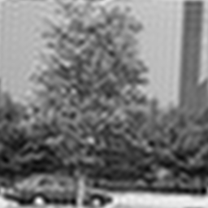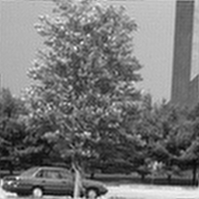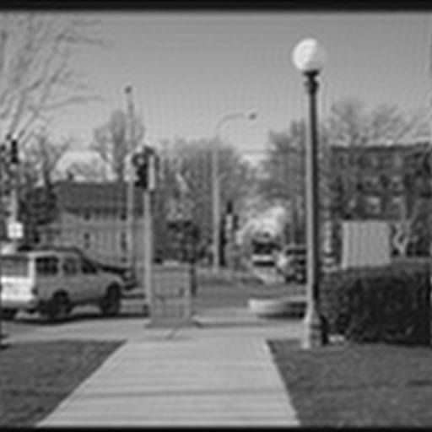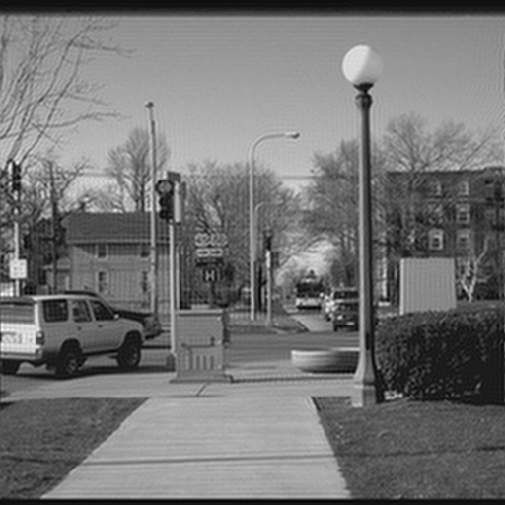

Freq=0.1

Freq=0.2

Freq=0.1

Freq=0.2

We apply a low pass filter to the image’s spectrum, which means we only pass signals with a frequency lower than a certain cutoff frequency and attenuates signals with frequencies higher than the cutoff frequency. Considering the lowest cutoff frequency that can be applied to the test image without causing a significant degradation of image quality is small, most of the information content in the Fourier domain has low frequencies. Comparing these two images, I think the lowest cut-off frequency of univ.png that without causing a significant degradation is smaller than that of roll.png, which means univ.png contains more low frequency content than roll.png.

In lab 1, we local block averaging (down sampling) the image, and in lab 2, we low pass filtering the image. The common points are they both blur the image. For the differences, first, the result of local block averaging is usually aliasing, while we can avoid aliasing by low pass filtering the image. Second, the image is pixelated by the local block averaging, while applying low pass filter only gives a smoothing blur version of the original image.

In lab 1, we local block averaging (down sampling) the image, which means we remove D-1 out of every D samples (D = 16 for lab 1), *y*[*m* ,*n*, *k*]=*x*[ *mD*, *nD*, *k*]. The result is usually aliasing. In the Fourier transform domain, the aliasing is expressed by overlap of the spectrum: $Y\left(ω\right)=(\frac{1}{D})\sum_{d=0}^{D-1}{X\left(\frac{ω-2πd}{D}\right).}$

(Low pass filter is a small, square-sized, simple convolution filters (kernels) which used to blur an image with the convolution option in the spatial domain. The simplest filter is just an equally-weighted, square array. That is all the values are ones, which are normalized by dividing by their sum before applying the convolution. This is equivalent to a local or neighborhood average. However, we do local block averaging in lab 1, which is not low pass filtering.)

**III. Conclusion**

For the magnitude-only reconstructed image, it is corrupted beyond recognition. The phase-only reconstruction preserve features, the images can be recognized. It is the phase image that actually contains most of the position information of the image, while the magnitude actually holds much of the color information. This is not exact, as there is some overlap in the information, but that is generally the case. The magnitude component, which essentially specifies all the frequencies that go to make up the image, only contains positive values, and is just directly mapped into image values. It has no fixed range of values, though except for the DC or zero frequency color, the values will generally be quite small. The phase component however ranges from -π to +π. As A zero phase will have a pure-gray value. In conclusion, the magnitude tells "how much" of a certain frequency component is present and the phase tells "where" the frequency component is in the image.

After applying a low pass filter to the image, it gives a blur version of the original image. The image that with smaller cut off frequency produce more blurring image. Low pass filtering smooths a image. The low frequency components (smooth variations) constitute the base of an image, and the high frequency components (the edges which give the detail) add upon them to refine the image, thereby giving a detailed image. Hence, the smooth variations are demanding more importance than the details. Smoothing can helps remove noise and be used to target specific types pf noise.